Hi Friends,

Check this attached images.

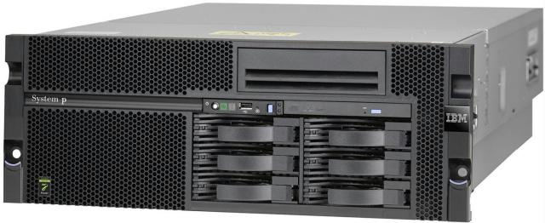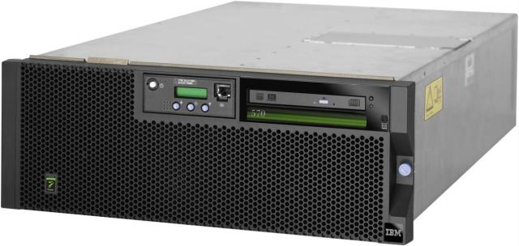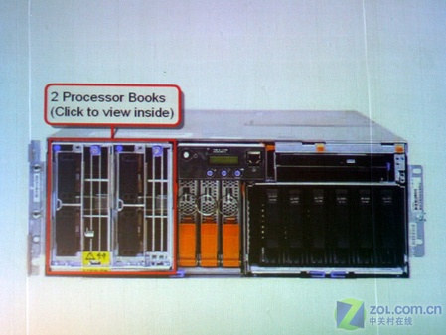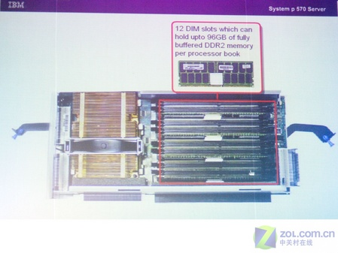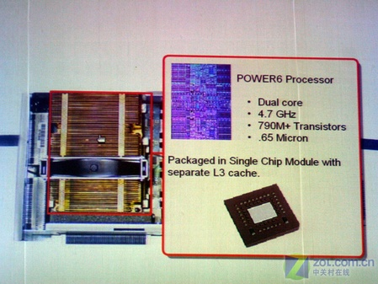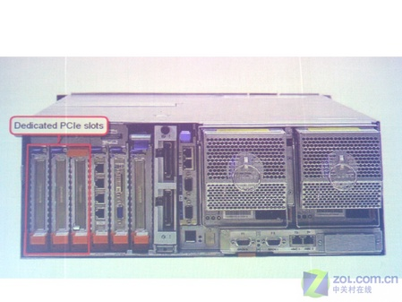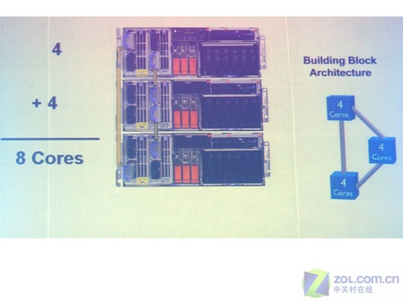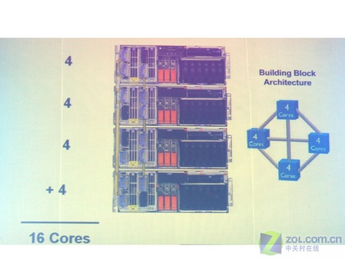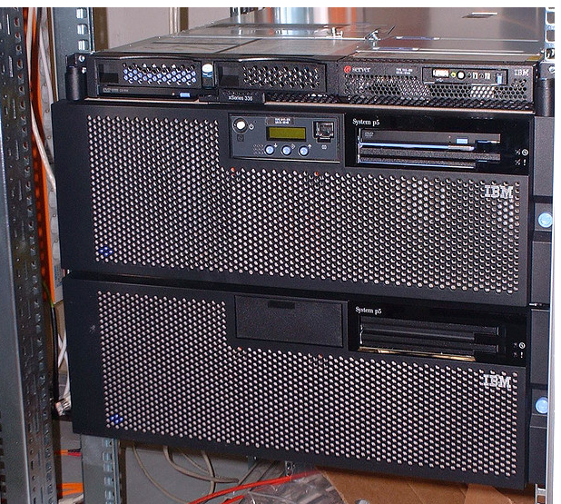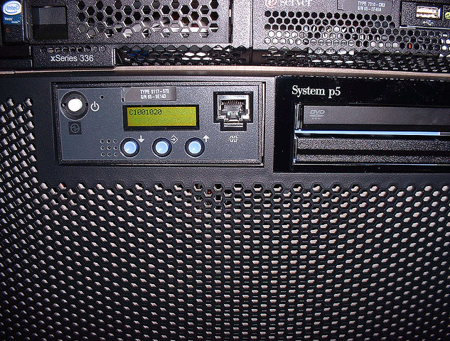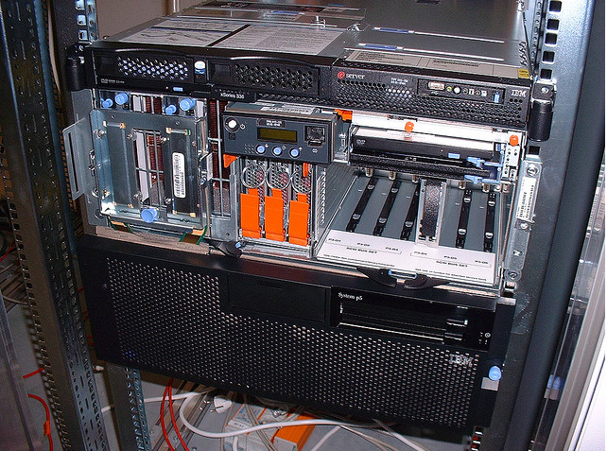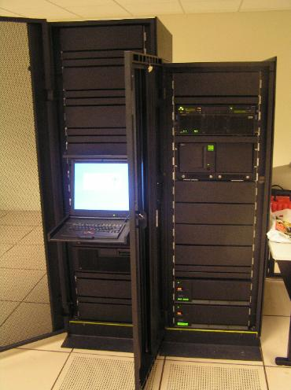

***Regards,***

***Kamesh Bakthan***

*Unix SA Support | TCS BFS BPO*

*Group Contact: +91-44-66218404 | Group Maill: *TCSeSV IN UNIX SA*

*Feedback & Team Lead Escalation: Niraj Bhange | +91-22-61329410 |* [*bzn.niraj.bhange@citi.com*](mailto:bzn.niraj.bhange@citi.com)

*Feedback & Managerial Escalation: Abhishek Roy | +91-22-61329407 |* [*abhishek3.roy@citi.com*](mailto:abhishek3.roy@citi.com)

